**22**

**3**

**LAPORAN PRAKTIKUM**

**ALGORITMA DAN PEMROGRAMAN 1**

**Pertemuan Ke-1**



**Disusun Oleh :**

|  |  |
| --- | --- |
| **NAMA** | **: NANANG SETYAWAN** |
| **NIM** | **: 185410025** |
| **JURUSAN** | **: Teknik Informatika** |
| **JENJANG** | **: S1** |

**STMIK AKAKOM**

**YOGYAKARTA**

**2018**

**LISTING**

**PRAKTIK 1**

**public class Text01{**

**public static void main(String[] args){**

**System.out.println(" /\\ /\\ ");**

**System.out.println(" / \\_______/ \\ ");**

**System.out.println("/ \\");**

**System.out.println("( /\\ /\\ )");**

**System.out.println("==== V ====");**

**System.out.println(" ==== (_|_) ====");**

**System.out.println(" ( ) ");**

**System.out.println(" (___________) ");**

**}**

**}**

**Hasilnya :**

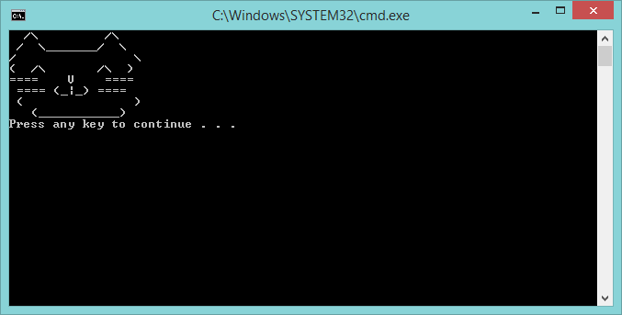

**PRAKTIK 2**

**public class Text02 {**

**public static void main(String[]args){**

**System.out.println("My name is Nanang");**

**System.out.println("Nanang is so cool");**

**System.out.println("Hooray Nanang!");**

**System.out.println("Please enjoy Nanang Apreciation "**

**+" Day! My name is Nanang. I know how exited "**

**+"everyone is to start appreciating Nanang on Nanang "**

**+"appreciation Day! Nanang, Nanang, Nanang! Yay "**

**+"Nanang!!! That's me! Nanang is the best date ever!");**

**}**

**}**

**Hasilnya :**

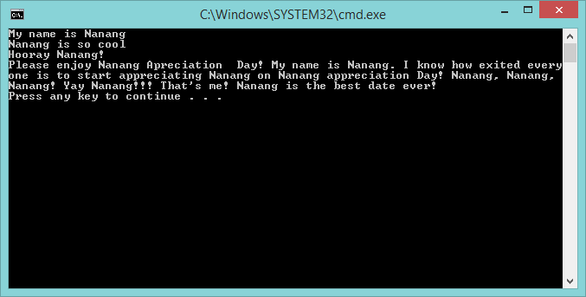

**PRAKTIK 3**

**public class Text03{**

**public static void main(String[] args){**

**String x = "Nanang";**

**System.out.println("My name is "+x);**

**System.out.println(x+" is so cool!");**

**System.out.println("Hooray "+x+"!");**

**System.out.println("Please enjoy "+x+" Appreciation"**

**+" day! My name is "+x+". I know how exited"**

**+" everyone is to start appreciating "+x+" on "+x**

**+" appreciation Day! "+x+", "+x+", "+x+"! Yay "**

**+x+"!! That's me! "+x+" is best date ever!");**

**}**

**}**

**Hasilnya :**

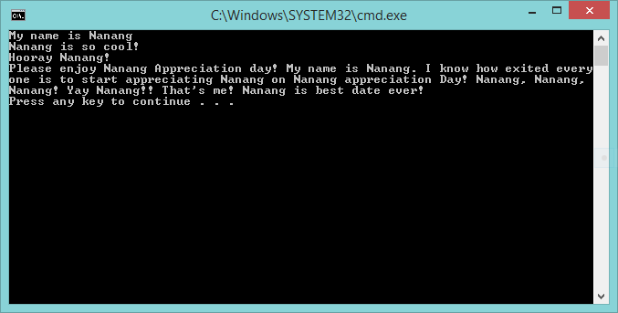

**PRAKTIK 4**

**public class Text04{**

**public static void main(String[]args){**

**String x ="Kitty";**

**System.out.println(x);**

**x ="Bunny";**

**System.out.println(x);**

**System.out.println();**

**String y ="Kitty";**

**System.out.println(x);**

**System.out.println(y);**

**}**

**}**

**Hasilnya :**

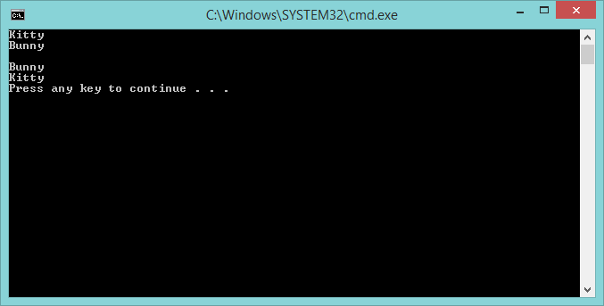

**PRAKTIK 5**

**public class Variabel01{**

**public static void main(String[]args){**

**boolean bool =true;**

**int intVar1 =1;**

**int intVar2 =2;**

**int intVar3 =3;**

**double doubleVar1, doubleVar2, doubleVar3, doubleVar4;**

**doubleVar1 =1.2;**

**doubleVar2 =2.1;**

**doubleVar3 =3.1;**

**}**

**}**

**Hasilnya :**

